January 8, 2020

(5:00 P.M.)

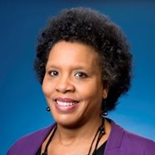
Council Member Brenda Priestly Jackson

District 10
Town Hall Meeting

Notice is hereby given that the Honorable Brenda Priestly Jackson will host a District 10 Town Hall meeting on Wednesday, January 29, 2020 at 6:00 p.m. – 7:30 p.m. in the Large Community Room of the Legends Center (5130 Soutel Drive, Jacksonville, FL 32208). During the meeting, Councilwoman Priestly Jackson will connect with attending community members of District 10 and provide them with important updates. All interested parties are invited to attend.

Please contact Kendra Mervin at (904) 255-5146 for additional information or correspondence.

BPJ/km

cc: Council Members/Staff
Cheryl L. Brown, Director/Council Secretary
Jessica Matthews, Chief of Legislative Services
Jeff Clements, Chief of Research
Kristi Sikes, Chief of Administrative Services
CITYC@COJ.NET
Office of General Counsel
Posted Notice Board – 1st Floor City Hall
Electronic Notice Kiosk – 1st Floor City Hall
Public Notice System – City Council Web Page
Media Box
File Box

